Table S1 Field experiments conducted at IRRI, Philippines between the 2014Wet-Season and 2015 Dry-Season
Set | Year | Season | Condition | Water management | Sowing date | Stress Initiation date | Trial Yield Mean (kg/ha) | Yield reduction | Stress level*
1 | 2014 | Wet | Transplanted | Irrigated | 27/06/14 | - | 1655 | - | -
2 | 2014 | Wet | Transplanted | Reproductive-Stress | 07/07/14 | 01/09/14 | 595 | 64 | Severe
3 | 2014 | Wet | Direct-seeded | Reproductive-Stress | 07/07/14 | 01/09/14 | 707 | 57 | Moderate
4 | 2015 | Dry | Transplanted | Irrigated | 16/12/14 | - | 5214 | - | -
5 | 2015 | Dry | Transplanted | Reproductive-Stress | 06/01/15 | 27/02/15 | 128 | 98 | Very Severe
6 | 2015 | Dry | Direct-seeded | Reproductive-Stress | 31/01/15 | 27/02/15 | 322 | 94 | Very Severe
* Control—continuous irrigation with no yield reduction due to water stress; moderate—yield reduction of 40–60%; severe—yield reduction of 60–85%; very severe—yield reduction of more than 85% as compared with control.

Table S2 Characterisation of the marker set of 215,250 SNPs
 |  | Rice 12 chromosomes
Table S2 | Chr | Chr1 | Chr2 | Chr3 | Chr4 | Chr5 | Chr6 | Chr7 | Chr8 | Chr9 | Chr10 | Chr11 | Chr12 | All
Table S2 | Size (bp) | 43,254,181 | 35,933,118 | 36,411,206 | 35,498,858 | 29,956,679 | 31,236,551 | 29,671,737 | 28,438,543 | 22,936,631 | 23,202,713 | 29,017,568 | 27,530,374 | 373,088,159
Distribution of distance (kb) between two adjacent SNP loci | Number | 22,346 | 21,868 | 15,483 | 23,830 | 14,719 | 16,291 | 15,204 | 19,330 | 12,224 | 11,215 | 26,015 | 16,725 | 215,250
Distribution of distance (kb) between two adjacent SNP loci | density | 1,936 | 1,643 | 2,352 | 1,490 | 2,035 | 1,917 | 1,952 | 1,471 | 1,876 | 2,069 | 1,115 | 1,646 | 1,733
Distribution of distance (kb) between two adjacent SNP loci | Minimum | 137 | 211 | 236 | 179 | 302 | 37 | 263 | 179 | 253 | 48 | 8 | 274 | 177
Distribution of distance (kb) between two adjacent SNP loci | 1st Quartile | 373 | 337 | 360 | 300 | 354 | 407 | 404 | 413 | 397 | 344 | 462 | 391 | 378
Distribution of distance (kb) between two adjacent SNP loci | Median | 472 | 493 | 387 | 438 | 456 | 476 | 457 | 650 | 530 | 412 | 773 | 497 | 503
Distribution of distance (kb) between two adjacent SNP loci | 3rd Quartile | 574 | 688 | 440 | 743 | 572 | 581 | 578 | 904 | 628 | 576 | 1,231 | 695 | 684
Distribution of distance (kb) between two adjacent SNP loci | Maximum | 1,077 | 3,549 | 821 | 3,089 | 1,066 | 1,092 | 1,077 | 1,216 | 1,103 | 893 | 1,916 | 1,690 | 1,549
Distribution of the minor allele frequency (MAF) | Minimum | 0.02 | 0.02 | 0.02 | 0.02 | 0.02 | 0.02 | 0.02 | 0.02 | 0.02 | 0.02 | 0.02 | 0.02 | 0.02
Distribution of the minor allele frequency (MAF) | 1st Quartile | 0.04 | 0.04 | 0.04 | 0.04 | 0.04 | 0.04 | 0.04 | 0.04 | 0.04 | 0.04 | 0.04 | 0.04 | 0.04
Distribution of the minor allele frequency (MAF) | Median | 0.11 | 0.10 | 0.10 | 0.09 | 0.08 | 0.10 | 0.08 | 0.10 | 0.09 | 0.10 | 0.11 | 0.10 | 0.09
Distribution of the minor allele frequency (MAF) | 3rd Quartile | 0.24 | 0.24 | 0.22 | 0.21 | 0.19 | 0.22 | 0.18 | 0.23 | 0.21 | 0.24 | 0.24 | 0.22 | 0.22
Distribution of the minor allele frequency (MAF) | Maximum | 0.50 | 0.50 | 0.50 | 0.50 | 0.50 | 0.50 | 0.50 | 0.50 | 0.50 | 0.50 | 0.50 | 0.50 | 0.50
Distribution of heterozygosity across chromosomes/ sites | Minimum | 0.00% | 0.00% | 0.00% | 0.00% | 0.00% | 0.00% | 0.00% | 0.00% | 0.00% | 0.00% | 0.00% | 0.00% | 0.00%
Distribution of heterozygosity across chromosomes/ sites | 1st Quartile | 0.00% | 0.00% | 0.00% | 0.00% | 0.00% | 0.00% | 0.00% | 0.00% | 0.00% | 0.00% | 0.00% | 0.00% | 0.00%
Distribution of heterozygosity across chromosomes/ sites | Median | 0.36% | 0.36% | 0.36% | 0.36% | 0.36% | 0.36% | 0.36% | 0.36% | 0.36% | 0.36% | 0.36% | 0.36% | 0.36%
Distribution of heterozygosity across chromosomes/ sites | 3rd Quartile | 1.07% | 1.07% | 1.07% | 1.07% | 1.07% | 1.07% | 1.43% | 1.07% | 1.43% | 1.43% | 1.07% | 1.43% | 1.19%
Distribution of heterozygosity across chromosomes/ sites | Maximum | 5.00% | 5.00% | 5.00% | 5.00% | 5.00% | 5.00% | 5.00% | 5.00% | 5.00% | 5.00% | 5.00% | 5.00% | 5.00%

Table S3 Validation results for the significant MTAs identified for ten traits in the study
Trait | QTL | Environment | Chro | Position | Region (Mb) | MSU_Gene | QTL/ gene designation
HI |  | LL_N | 1 | 1670618
GY | qGY₁₋₁ | UL_S | 1 | 3473291 | 0.351331
GY | qGY₁₋₁ | LL_S | 1 | 3824622 | 0.351331
HI |  | UL_S | 1 | 4520401
HI |  | UL_S | 1 | 5997070
HI |  | UL_S | 1 | 7448895
SPKFT |  | LL_N | 1 | 14729531
SPKFT |  | LL_N | 1 | 15696481
GY |  | LL_S | 1 | 17515001
PH |  | LL_S | 1 | 17986986
GY |  | UL_S | 1 | 24237011
GY |  | UL_S | 1 | 24304274 |  | LOC_Os01g43450 | expressed protein
GY |  | UL_S | 1 | 27277198
PH | qPH₁₋₁ | LL_N | 1 | 33418648 | 0.981697 | LOC_Os01g53670 | ENTH domain containing protein C expressed
PH | qPH₁₋₁ | UL_S | 1 | 33689947 | 0.981697
PH | qPH₁₋₁ | LL_S | 1 | 34359106 | 0.981697
PH | qPH₁₋₁ | LL_N | 1 | 34400345 | 0.981697
PH | qPH₁₋₁ | LL_S | 1 | 34400345 | 0.981697 | LOC_Os01g59760 | bZIP transcription factor C putative C expressed
NBP |  | LL_N | 1 | 37770897 |  |  | qDTY_{1.1}
PH | qPH₁₋₂ | LL_N | 1 | 37960019 | 1.084762 |  | qDTY_{1.1}
PH | qPH₁₋₂ | UL_S | 1 | 38418739 | 1.084762 |  | qDTY_{1.1}
PH | qPH₁₋₂ | UL_S | 1 | 39044781 | 1.084762 |  | qDTY_{1.1}
GY | qGY₁₋₂ | LL_S | 1 | 39987434 | 0.403093 |  | qDTY_{1.1}
GY | qGY₁₋₂ | LL_S | 1 | 40017809 | 0.403093 |  | qDTY_{1.1}
GY | qGY₁₋₂ | UL_S | 1 | 40390527 | 0.403093 |  | qDTY_{1.1}
NBP |  | LL_N | 1 | 42056650
PH |  | LL_N | 2 | 7074179
HSW |  | LL_N | 2 | 8191777
GY |  | UL_S | 2 | 12985560
HSW |  | LL_N | 2 | 13051747
BMDW |  | LL_N | 2 | 13987526
BMDW |  | LL_N | 2 | 15644298
BMDW |  | LL_N | 2 | 17808669 |  | LOC_Os02g30270 | expressed protein
GY | qGY₂₋₁ | UL_S | 2 | 18794394 | 4.271539
GY | qGY₂₋₁ | UL_S | 2 | 19821147 | 4.271539
GY | qGY₂₋₁ | UL_S | 2 | 20248668 | 4.271539 | LOC_Os02g33620 | retrotransposon protein C putative C unclassified C expressed
GY | qGY₂₋₁ | UL_S | 2 | 20774488 | 4.271539
GY | qGY₂₋₁ | UL_S | 2 | 21953460 | 4.271539 | LOC_Os02g36190 | cytochrome P450 C putative C expressed
GY | qGY₂₋₁ | UL_S | 2 | 22142784 | 4.271539
GY | qGY₂₋₁ | UL_S | 2 | 22201226 | 4.271539
GY | qGY₂₋₁ | UL_S | 2 | 23065933 | 4.271539
SPKFT |  | UL_S | 2 | 24695278
HI |  | LL_N | 2 | 24797737 |  | LOC_Os02g40920 | transposon protein C putative C CACTA C En FSpm sub-class C expressed
HI |  | LL_N | 2 | 25205930 |  | LOC_Os02g42020 | expressed protein
GY | qGY₂₋₂ | UL_S | 2 | 25979458 |  |  | qDTY_{2.3}
GY | qGY₂₋₂ | UL_S | 2 | 29167141 |  |  | qDTY_{2.3}
NBP |  | LL_S | 2 | 34406178
PH |  | LL_N | 2 | 34710697
HSW |  | LL_S | 3 | 4775424
HI |  | LL_N | 3 | 12571062
GY |  | UL_S | 3 | 13543585
NBP |  | LL_N | 3 | 14390997
GY |  | UL_S | 3 | 28646420 |  | LOC_Os03g49650 | retrotransposon protein C putative C Ty1-copia subclass
PH |  | LL_S | 3 | 33600040 |  | LOC_Os03g58220 | transposon protein C putative C unclassified C expressed
PH |  | LL_S | 3 | 33600989 |  | LOC_Os03g58220 | transposon protein C putative C unclassified C expressed
GY |  | UL_S | 4 | 445488
GY |  | UL_S | 4 | 801040
GY |  | UL_S | 4 | 1441702 |  | LOC_Os04g25400 | uncharacterized protein all1601 C putative C expressed
GY |  | UL_S | 4 | 1598504
SPKFT |  | LL_N | 4 | 6528566
SPKFT |  | LL_N | 4 | 7496029
SPKFT |  | UL_S | 4 | 15860075
HSW |  | LL_S | 4 | 19096486
NBP |  | LL_N | 4 | 22161787
GY |  | LL_S | 4 | 25920763 |  | LOC_Os04g37410 | expressed protein
GY |  | LL_S | 4 | 31088649 |  | LOC_Os04g50150 | retrotransposon protein C putative C unclassified C expressed
PH |  | LL_S | 4 | 31375912
GY / HI |  | UL_S | 5 | 352058
GY |  | UL_S | 5 | 594868
GY |  | UL_S | 5 | 722162
GY |  | UL_S | 5 | 2683697
GY / HI / SPKFT | qGY₅₋₁ | UL_S | 5 | 4140355 | 0.365282
GY / HI | qGY₅₋₁ | UL_S | 5 | 4266313 | 0.365282
GY | qGY₅₋₁ | UL_S | 5 | 4502747 | 0.365282
GY | qGY₅₋₁ | UL_S | 5 | 4502961 | 0.365282
GY | qGY₅₋₁ | UL_S | 5 | 4505637 | 0.365282
HI |  | UL_S | 5 | 5357669
GY |  | UL_S | 5 | 5522232
GY |  | UL_S | 5 | 5824772
HI |  | LL_N | 5 | 5891992 |  | LOC_Os05g10700 | retrotransposon protein C putative C unclassified C expressed
GY |  | UL_S | 5 | 6254266
HI |  | UL_S | 5 | 6523238
SPKFT |  | UL_S | 5 | 6747589
GY |  | UL_S | 5 | 7777995
HI |  | UL_S | 5 | 8338589
HI |  | UL_S | 5 | 8505783
GY |  | UL_S | 5 | 12494100 |  | LOC_Os05g20900 | retrotransposon protein C putative C unclassified
GY |  | UL_S | 5 | 14325590
GY |  | LL_S | 5 | 19224697 |  | LOC_Os05g32660 | leucine-rich repeat family protein C putative C expressed
GY | qGY₅₋₂ | UL_S | 5 | 24708194 | 5.205446 |  | OsRPK1, OsCCaMK, OsHAP3B, OsTPS1, OsSTN8
GY | qGY₅₋₂ | UL_S | 5 | 29913640 | 5.205446 |  | OsRPK1, OsCCaMK, OsHAP3B, OsTPS1, OsSTN8
GY |  | UL_S | 6 | 3233993
GY |  | UL_S | 6 | 3723575
GY |  | UL_S | 6 | 5883556
GY |  | UL_S | 6 | 6025083 |  | LOC_Os06g11540 | retrotransposon protein C putative C unclassified C expressed
GY |  | UL_S | 6 | 7472450
DTF | qDTF₆₋₁ | LL_N | 6 | 7611279 | 0.138131
DTF | qDTF₆₋₁ | LL_N | 6 | 7749410 | 0.138131
DTF | qDTF₆₋₂ | LL_N | 6 | 9539728 | 0.8318
DTF | qDTF₆₋₂ | LL_N | 6 | 10279310 | 0.8318
DTF | qDTF₆₋₂ | LL_N | 6 | 10371528 | 0.8318
GY |  | UL_S | 6 | 12392812
PH |  | LL_N | 6 | 13439145 |  |  | OsPT9, OsPT1055,OsGLK1, nyc3
HSW |  | LL_S | 6 | 16493040
PH |  | LL_N | 6 | 19486804
GY |  | UL_S | 6 | 22794237 |  | LOC_Os06g37850 | transposon protein C putative C CACTA C En FSpm sub-class C expressed
GY |  | UL_S | 6 | 23132086 |  | LOC_Os06g39690 | SOUL heme-binding protein C putative C expressed
HSW |  | LL_S | 6 | 23403566
GY |  | UL_S | 6 | 26672678
GY |  | UL_S | 6 | 27655258 |  | LOC_Os06g47030 | expressed protein
SPKFT |  | UL_S | 6 | 28876857 |  | LOC_Os06g49060 | ternary complex factor MIP1 C putative C expressed
HI |  | UL_S | 6 | 29380888
PH |  | LL_N | 6 | 30802585
PH |  | LL_N | 6 | 30807826
GY |  | UL_S | 6 | 31179920 |  | LOC_Os06g49910 | retrotransposon protein C putative C unclassified
DTF |  | LL_S | 7 | 5093247
GY |  | UL_S | 7 | 11494665
GY |  | UL_S | 7 | 12116041
HI |  | LL_S | 7 | 12460909
GY |  | UL_S | 7 | 13019061 |  | LOC_Os07g23450 | ZOS7-04 - C2H2 zinc finger protein C expressed
GY |  | UL_S | 7 | 14683350
NBP |  | LL_S | 7 | 15048319
GY |  | UL_S | 7 | 15125997
GY |  | UL_S | 7 | 16180595 |  | LOC_Os07g27900 | retrotransposon protein C putative C Ty1-copia subclass
GY |  | UL_S | 7 | 16181810 |  | LOC_Os07g27900 | retrotransposon protein C putative C Ty1-copia subclass
GY |  | UL_S | 7 | 16183053 |  | LOC_Os07g27900 | retrotransposon protein C putative C Ty1-copia subclass
SPKFT |  | LL_N | 7 | 16855834
SPKFT |  | LL_N | 7 | 18448562
DTF |  | LL_N | 7 | 19598023 |  | LOC_Os07g32800 | autophagy-related protein C putative C expressed
PH |  | LL_S | 7 | 19689644
DTF |  | LL_N | 7 | 20159780 |  | LOC_Os07g32820 | expressed protein
SPKFT |  | LL_N | 7 | 27596132
BMDW | qBMDW₈₋₁ | LL_S | 8 | 466752 | 0.075182
BMDW | qBMDW₈₋₁ | LL_S | 8 | 500943 | 0.075182
BMDW | qBMDW₈₋₁ | LL_S | 8 | 541934 | 0.075182
PH |  | UL_S | 8 | 654862
GY / HI |  | UL_S | 8 | 857745
GY |  | UL_S | 8 | 2601016
PH |  | LL_N | 8 | 3543841
GY |  | UL_S | 8 | 4420926
DTF |  | LL_S | 8 | 5367927
GY |  | UL_S | 8 | 5755212
GY |  | UL_S | 8 | 6119419
GY |  | UL_S | 8 | 6560107
DTF |  | LL_N | 8 | 17075677
HSW |  | LL_S | 8 | 19133569
NBP |  | LL_S | 8 | 20972048
NBP |  | LL_N | 8 | 22460760
HI |  | LL_S | 8 | 24471764
GY |  | UL_S | 9 | 366317
NBP |  | LL_S | 9 | 990034
SPKFT |  | LL_N | 9 | 1671524
GY |  | UL_S | 9 | 3032058 |  | LOC_Os09g06650 | retrotransposon C putative C centromere-specific C expressed
SPKFT |  | LL_N | 9 | 4622275
GY |  | UL_S | 9 | 5467194 |  | LOC_Os09g10300 | Skp1 family C dimerisation domain containing protein C expressed
GY |  | UL_S | 9 | 7290176
SPKFT | qSPKFT₉₋₁ | LL_N | 9 | 9426722 | 2.41142
SPKFT | qSPKFT₉₋₁ | LL_N | 9 | 10118145 | 2.41142
PH | qSPKFT₉₋₁ | LL_S | 9 | 11072513 | 2.41142
SPKFT | qSPKFT₉₋₁ | LL_N | 9 | 11791517 | 2.41142
SPKFT | qSPKFT₉₋₁ | LL_N | 9 | 11838142 | 2.41142
PH | qPH₉₋₁ | UL_S | 9 | 13423222 |  |  | qDTY_{9.1}
DTF | qPH₉₋₁ | LL_S | 9 | 13934171 |  |  | qDTY_{9.1}
PH | qPH₉₋₁ | LL_N | 9 | 15970207 |  |  | qDTY_{9.1}
PH | qPH₉₋₁ | UL_S | 9 | 16154337 |  |  | qDTY_{9.1}
BMDW / NBP | qBMDW-NBP₉₋₁ | LL_N | 9 | 19316065 | 2.021488 | LOC_Os09g36290 | Ser FThr protein phosphatase family protein C putative C expressed
NBP | qBMDW-NBP₉₋₁ | LL_N | 9 | 20908000 | 2.021488
BMDW / NBP | qBMDW-NBP₉₋₁ | LL_N | 9 | 20944019 | 2.021488 | LOC_Os09g36330 | expressed protein
NBP | qBMDW-NBP₉₋₁ | LL_N | 9 | 21337553 | 2.021488
GY |  | UL_S | 10 | 4716948
SPKFT |  | LL_N | 10 | 5092509
GY |  | UL_S | 10 | 9297675
DTF |  | LL_S | 11 | 2557438
HSW |  | LL_N | 11 | 2678930
PH |  | LL_N | 11 | 5630523
DTF | qDTF₁₁₋₁ | LL_S | 11 | 6525213 | 0.690727
DTF | qDTF₁₁₋₁ | LL_S | 11 | 6604428 | 0.690727
DTF | qDTF₁₁₋₁ | LL_S | 11 | 6602990 | 0.690727
DTF | qDTF₁₁₋₁ | LL_S | 11 | 7215923 | 0.690727 | LOC_Os11g12760 | O-methyltransferase C putative C expressed
DTF | qDTF₁₁₋₁ | LL_S | 11 | 7215940 | 0.690727 | LOC_Os11g12760 | O-methyltransferase C putative C expressed
HI |  | UL_S | 11 | 10053723 |  | LOC_Os11g18366 | cycloartenol synthase C putative C expressed
HI |  | LL_N | 11 | 10351950 |  | LOC_Os11g19230 | retrotransposon protein C putative C Ty1-copia subclass C expressed
SPKFT |  | UL_S | 11 | 11165817
GY |  | LL_S | 11 | 11817831
PH |  | UL_S | 11 | 15756517
GY |  | UL_S | 11 | 16248710 |  |  | qGP-11, qGI-11, yld11.1, gpl11.1, gl11.1
DTF |  | LL_S | 11 | 18836588 |  | LOC_Os11g31980 | OsSCP63 - Putative Serine Carboxypeptidase homologue C expressed
PH |  | LL_N | 11 | 20143839 |  | LOC_Os11g34364 | armadillo Fbeta-catenin-like repeat containing protein C expressed
GY |  | UL_S | 11 | 20668615 |  | LOC_Os11g35310 | phytosulfokines precursor C putative C expressed
GY |  | UL_S | 11 | 21092857
GY |  | UL_S | 11 | 21311326 |  | LOC_Os11g36200 | receptor-like protein kinase 2 precursor C putative C expressed
PH |  | UL_S | 11 | 22175365 |  |  | qGP-11,qGl-11, yld11.1, gpl11.1, gw11.1
HI |  | LL_N | 11 | 23022593 |  |  | qGP-11,qGl-11, yld11.1, gpl11.1, gw11.1
SPKFT |  | UL_S | 11 | 24636744
PH |  | LL_S | 11 | 24761315
PH |  | UL_S | 11 | 25597507
GY |  | UL_S | 11 | 26464313
PH |  | LL_S | 11 | 28779480
PH |  | LL_S | 11 | 28789891
GY |  | LL_S / UL_S | 12 | 1642245
GY |  | UL_S | 12 | 2835650 |  | LOC_Os12g06020 | mRNA-decapping enzyme C putative C expressed
GY |  | UL_S | 12 | 3848827
GY |  | UL_S | 12 | 4340342
GY |  | UL_S | 12 | 7226659
DTF |  | LL_S | 12 | 7712803
GY |  | UL_S | 12 | 7778770
DTF |  | LL_N | 12 | 9203018
HI |  | UL_S | 12 | 10391392
HSW |  | LL_S | 12 | 11404416
GY |  | UL_S | 12 | 11591239
GY |  | UL_S | 12 | 12177156
GY |  | UL_S | 12 | 12704766
PH |  | LL_N | 12 | 16502509
HI |  | LL_S | 12 | 17641543
GY | qGY₁₂₋₁ | UL_S | 12 | 18165164 | 0.941182 |  | qDTY_{12.1}
GY | qGY₁₂₋₁ | UL_S | 12 | 18597220 | 0.941182 |  | qDTY_{12.1}
GY | qGY₁₂₋₁ | UL_S | 12 | 19106346 | 0.941182 |  | qDTY_{12.1}
HI |  | LL_N | 12 | 23250434 |  | LOC_Os12g37850 | expressed protein
HSW |  | LL_S | 12 | 24105210

Table S4 Details of the 280 diversity panel accessions
S.No | Study designation | 3KG database designation | Parentage | IRGC Acc. No. | Orgin | GID | Sub-population* | Landrace (0) / improved (1)
1 | RP002 | 19::IRGC 70786-1 | 19 | 127096 | India | 4063314 | ind2 | 0
2 | RP003 | 3210::IRGC 116950-1 | CR 94-13/IR 1529//IR 1818-1-19-2 | 127030 | Sri Lanka | 4006013 | ind1B | 1
3 | RP004 | 498-2A BR 8::IRGC 5891-1 | 498-2A BR 8 | 126041 | India | 3944249 | ind2 | 1
4 | RP005 | ADT 12::IRGC 6254-1 | CHITRAI KALI | 127107 | India | 4063338 | ind2 | 0
5 | RP006 | AE NOUA::IRGC 89308-1 | AE NOUA | 127110 | Lao Pdr | 4063344 | indx | 0
6 | RP007 | ALTAMIRA 9::IRGC 116953-1 | ORYZICA 1//P 1897-15-1-4-1-1B/COSTA RICA | 127031 | Nicaragua | 4006014 | indx | 1
7 | RP008 | ARAURE 1::IRGC 116956-1 | IR 930-147-13/COLOMBIA 1 | 125950 | Venezuela | 3943915 | ind1B | 1
8 | RP009 | ARC 10100::IRGC 20709-1 | ARC 10100 | 121185 | India | 3625341 | aus | 0
9 | RP010 | ARC 10594::IRGC 12524-1 | ARC 10594 | 125636 | India | 3943989 | indx | 0
10 | RP011 | ARC 10754::IRGC 12603-1 | ARC 10754 | 125637 | India | 3943991 | indx | 0
11 | RP012 | ARC 10812::IRGC 21074-1 | ARC 10812 | 126173 | India | 3973290 | indx | 0
12 | RP013 | ARC 11524::IRGC 42672-1 | ARC 11524 | 125641 | India | 3943996 | indx | 0
13 | RP014 | ARC 11857::IRGC 40972-1 | ARC 11857 | 125643 | India | 3943998 | indx | 0
14 | RP015 | ARC 11901::IRGC 21727-1 | ARC 11901 | 127033 | India | 4006016 | indx | 0
15 | RP018 | ARC 13778::IRGC 41216-1 | ARC 13778 | 125647 | India | 3944002 | indx | 0
16 | RP019 | ARC 14060::IRGC 41374-1 | ARC 14060 | 125648 | India | 3944003 | ind2 | 0
17 | RP020 | ARC 14064::IRGC 41377-1 | ARC 14064 | 125649 | India | 3944004 | indx | 0
18 | RP021 | ARC 14654::IRGC 41663-1 | ARC 14654 | 125650 | India | 3944005 | ind2 | 0
19 | RP022 | ARC 15873::IRGC 43250-1 | ARC 15873 | 125653 | India | 3944008 | indx | 0
20 | RP023 | ARC 18092::IRGC 42256-1 | ARC 18092 | 125654 | India | 3944009 | indx | 0
21 | RP024 | ARC 18112::IRGC 42274-1 | ARC 18112 | 125655 | India | 3994770 | indx | 0
22 | RP025 | ARC 18202::IRGC 42328-1 | ARC 18202 | 126175 | India | 3973292 | indx | 0
23 | RP026 | ARC 18597::IRGC 43299-1 | ARC 18597 | 126043 | India | 3994863 | indx | 0
24 | RP028 | ASHI BINNI::IRGC 77216-1 | ASHI BINNI | 126131 | Bangladesh | 3973245 | indx | 0
25 | RP029 | ASHMBER::IRGC 27522-1 | ASHMBER | 125657 | Bangladesh | 3944012 | ind2 | 0
26 | RP030 | ASU::IRGC 62154-1 | ASU | 125658 | Bhutan | 3944013 | indx | 0
27 | RP031 | AUS 171::IRGC 29004-1 | BATHURI | 127178 | Bangladesh | 3635439 | aus | 0
28 | RP032 | AUS 177::IRGC 29009-1 | AUS 177 | 125659 | Bangladesh | 3944014 | ind1B | 0
29 | RP033 | AUS 219::IRGC 29031-1 | BATHURI | 127179 | Bangladesh | 3635439 | aus | 0
30 | RP034 | AUS 233::IRGC 29036-1 | BATHURI | 127180 | Bangladesh | 3635439 | aus | 0
31 | RP036 | AUS 295::IRGC 29083-1 | BATHURI | 127184 | Bangladesh | 3635439 | aus | 0
32 | RP037 | AUS 301::IRGC 29089-1 | BATHURI | 127186 | Bangladesh | 3635439 | aus | 0
33 | RP038 | AUS 308::IRGC 29096-1 | BATHURI | 127187 | Bangladesh | 3635439 | aus | 0
34 | RP039 | AUS 329::IRGC 29116-1 | BATHURI | 127188 | Bangladesh | 3635439 | aus | 0
35 | RP040 | AUS 344::IRGC 29131-1 | BATHURI | 127189 | Bangladesh | 3635439 | aus | 0
36 | RP041 | AUS 439::IRGC 29221-1 | AUS 439 | 120876 | Bangladesh | 3995286 | aus | 0
37 | RP042 | AUS PADDY (RED)::IRGC 44978-1 | BATHURI | 127192 | India | 3635439 | aus | 0
38 | RP043 | B 4414 F-MR-6-3::IRGC 117310-1 | PELITA I-1/W 1257//ARC 5756/IR 36 | 126044 | Indonesia | 3994852 | indx | 1
39 | RP044 | B 6136 E-3-TB-0-1-5::IRGC 117311-1 | TETEP/IR 36//KLEMAS | 125952 | Indonesia | 3943938 | ind1B | 1
40 | RP045 | B 6136-3-TB-0-1-5::IRGC 117312-1 | TETEP/IR 36//KLEMAS | 125951 | Indonesia | 3943918 | ind1B | 1
41 | RP046 | B 6149 F-MR-7::IRGC 117314-1 | ITA 117 (TOX 356-1-1-1)/B 1050 C-MR-18-2 | 125953 | Indonesia | 3943941 | indx | 1
42 | RP047 | BA BAI GU::IRGC 79580-1 | BA BAI GU | 125663 | China | 3944018 | indx | 0
43 | RP048 | BA SHI ZAO::IRGC 67903-1 | BA SHI ZAO | 125675 | China | 3943933 | ind1A | 0
44 | RP049 | BADAL 1163::IRGC 32796-1 | BADAL 1163 | 125664 | Bangladesh | 3944019 | ind2 | 0
45 | RP050 | BADUIE::IRGC 53715-1 | BADUIE | 125666 | India | 3944021 | ind2 | 0
46 | RP051 | BAI HE::IRGC 76438-1 | BAI HE | 125669 | China | 3943923 | ind1A | 0
47 | RP052 | BAIANG 6::IRGC 6129-1 | BAIANG 6 | 125668 | Indonesia | 3943921 | indx | 0
48 | RP053 | BAK TULSI::IRGC 34831-1 | BATHURI | 127205 | India | 3635439 | aus | 0
49 | RP054 | BAKASI::IRGC 27074-1 | BAKASI | 127204 | Indonesia | 4063480 | indx | 0
50 | RP055 | BALASURIYA A::IRGC 66509-1 | BALASURIYA A | 126178 | Sri Lanka | 3973295 | indx | 0
51 | RP056 | BAMOA A 75::IRGC 51101-1 | IR 262-43-8-11/NIAW SAN PAHTAWNG | 125671 | Mexico | 3943926 | indx | 1
52 | RP057 | BANDI::IRGC 17214-1 | BAKASI | 127207 | Indonesia | 4063480 | ind3 | 0
53 | RP058 | BANGKOUY::IRGC 94037-1 | KDM 65-G1 U-45/IR 11288-B-B-69-1//RD 19/IR 17494-32-3-1-1-3 | 127208 | Cambodia | indica | ind3 | 1
54 | RP059 | BARIK KUDI::IRGC 52807-1 | BARIK KUDI | 125674 | India | 3943932 | ind2 | 0
55 | RP060 | BAT DO::IRGC 7014-1 | BAT DO | 121599 | Viet Nam | 3625272 | indx | 0
56 | RP061 | BATHURI::IRGC 25838-1 | BATHURI | 120887 | Bangladesh | 3635439 | aus | 0
57 | RP062 | BAZAIL::IRGC 27526-1 | BAZAIL | 126184 | Bangladesh | 3973325 | indx | 0
58 | RP063 | BENGALY MORIMO::IRGC 10976-1 | IRAT 13/IRAT 10 | 125677 | Madagascar | 3944024 | ind2 | 1
59 | RP065 | BHADOIA 303::IRGC 6588-1 | BHADOIA 303 | 120894 | Bangladesh | 3408004 | aus | 0
60 | RP066 | BK 26::IRGC 45197-1 | BK 26 | 125684 | India | 3944036 | ind2 | 0
61 | RP067 | BKN BR 1031-78-5-4::IRGC 55927-1 | BKN BR 1031-78-5-4 | 127231 |  | 4063521 | indx | 1
62 | RP068 | BONG SEN::IRGC 7011-1 | BONG SEN | 127235 | Vietnam | 4063527 | ind3 | 0
63 | RP070 | BPI 76 NON SENSITIVE (GREEN)::IRGC 9790-1 | FORTUNA/SERAUP BESAR 15 | 120902 | Philippines | 3174060 | ind3 | 1
64 | RP071 | BR 51-115-4::IRGC 43999-1 | IRRISAIL/IR 5-114-3 | 127237 | Bangladesh | 4063530 | indx | 1
65 | RP072 | BR 5230-46-4::IRGC 117318-1 | NIZERSAIL/MALA-J15//NIZERSAIL/BR 51-282-8-HR 9///IRRISAIL/IR 5-114-3 | 121167 | Bangladesh | 3406493 | indx | 1
66 | RP073 | BR IRGA 409::IRGC 55915-1 | IR 930-2/IR 665-31-2-4 | 125691 | Brazil | 3944048 | ind1B | 1
67 | RP074 | BW 295-5::IRGC 63098-1 | OB 678/BW 254-1 | 125955 | Sri Lanka | 3943948 | ind1B | 1
68 | RP075 | C 1016-1::IRGC 50368-1 | C 22/SERATUS MALAM | 127243 | Philippines | 4063539 | indx | 1
69 | RP076 | C 166-135::IRGC 50633-1 | C 22/SERATUS MALAM | 127244 | Philippines | 4063539 | ind3 | 1
70 | RP077 | C 662083::IRGC 62101-1 | CHIANUNG SIPI 632063/CHIANUNG SEN YU 7 | 125692 | Chinese Taipei (Taiwan) | 3944050 | ind1B | 1
71 | RP079 | CAUVERY::IRGC 45255-1 | TAICHUNG NATIVE 1/TKM 6 | 125695 | India | 3944055 | indx | 0
72 | RP080 | CE IN TSAN::IRGC 4362-1 | CE IN TSAN | 127249 | China | 4063548 | ind1A | 0
73 | RP081 | CEA 3::IRGC 116965-1 | IR 22/SIGADIS (AICRIP) | 125957 | Paraguay | 3943955 | indx | 1
74 | RP082 | CEMPO MANGGAR::IRGC 27107-1 | CEMPO MANGGAR | 127250 | India | 4063549 | ind3 | 0
75 | RP083 | CHAKOL::IRGC 77226-1 | CHAKOL | 125696 | Bangladesh | 3994780 | ind2 | 0
76 | RP084 | CHAM LEK::IRGC 89387-1 | CHAM LEK | 127255 | Lao Pdr | 4063557 | indx | 0
77 | RP085 | CHAMA (DWARF)::IRGC 69487-1 | CV CHAMA (DWARF) | 125958 | Zambia | 3943959 | ind1B | 1
78 | RP086 | CHANDARHAT::IRGC 25845-1 | CHANDARHAT | 121605 | Bangladesh | 3626746 | aus | 0
79 | RP087 | CHANDINA::IRGC 36420-1 | IR 262-24-3/TKM 6 | 125699 | Sri Lanka | 3944062 | ind1B | 1
80 | RP088 | CHANG LE SAN SHU ZAO::IRGC 63561-1 | CHANG LE SAN SHU ZAO | 126115 | China | 3972942 | ind1A | 0
81 | RP089 | CHAO PEUAK DENG::IRGC 11602-1 | CHAM LEK | 127268 | Lao Pdr | 4063557 | ind3 | 0
82 | RP090 | CHI SHENG TAO::IRGC 4606-1 | CHI SHENG TAO | 125704 | China | 3944071 | ind1A | 0
83 | RP091 | CHIAYI WU-K'O::IRGC 64974-1 | CHIAYI WU-K'O | 127273 | Taiwan | 4063584 | ind1A | 0
84 | RP092 | CHIH SHEN LI::IRGC 1306-1 | CHIH SHEN LI | 125702 | China | 3944068 | ind1A | 0
85 | RP093 | CHNNOR::IRGC 67485-1 | CHNNOR | 125706 | India | 3944075 | indx | 0
86 | RP094 | CHUA DAU::IRGC 4785-1 | CHUA DAU | 120914 | China | 3995323 | indx | 0
87 | RP095 | CHUNGUR BALI::IRGC 25855-1 | CHUNGUR BALI | 120915 | Bangladesh | 3626534 | aus | 0
88 | RP096 | CICA 9::IRGC 53079-1 | IR 665-23-3-1//IR 841-63-5-104-1B/C 46-15 | 125713 | Colombia | 3944085 | ind1B | 1
89 | RP097 | CN 44-40-7::IRGC 45368-1 | ?/? | 127286 | India | 4063603 | indx | 0
90 | RP098 | CO 39::IRGC 51231-1 | CULT 340/KANNAGI | 117454 | India | 3995032 | indx | 1
91 | RP099 | CR 60-10::IRGC 15777-1 | CR 60-10 | 125715 | India | 3944088 | indx | 1
92 | RP100 | CRILLO LA FRIA::IRGC 10793-1 | CRIOLLO LA FRIA | 125716 | Venezuela | 3944090 | ind1A | 1
93 | RP101 | CSR-90 IR-2::IRGC 117327-1 | IR 10206-29-2-1/SUAKOKO (SEL) | 120921 | India | 3174041 | indx | 1
94 | RP102 | CT 9737-6-1-1-2-2P-M::IRGC 117330-1 | IR 21015-72-3-3-3-1/TOX 1816-102-3//P 5166-F2-26-1-1X | 120922 | Colombia | 3174040 | indx | 1
95 | RP103 | CUN GU NUO::IRGC 63576-1 | ?/? | 127288 | China | 4063603 | indx | 0
96 | RP104 | CUYAMEL 3820::IRGC 116975-1 | CICA 7// 2940/COSTA RICA | 125961 | Mexico | 3943969 | indx | 1
97 | RP105 | DA 11::IRGC 6046-1 | JESSOBALAM | 124431 | Bangladesh | 3804136 | ind2 | 0
98 | RP106 | DA GANG ZHAN::IRGC 67103-1 | DA GANG ZHAN | 125719 | China | 3944094 | indx | 0
99 | RP107 | DA NUO (ZHAN)::IRGC 72025-1 | DA NUO | 125723 | China | 3944100 | ind1A | 0
100 | RP108 | DAA MANSA::IRGC 67559-1 | DAA MANSA | 126196 | Ghana | 3973337 | ind1B | 0
101 | RP109 | DANGAR::IRGC 76296-1 | DANGAR | 120927 | India | 3406484 | aus | 0
102 | RP110 | DHANE BURWA::IRGC 10105-1 | DHANE BURWA | 126199 | India | 3973340 | ind2 | 0
103 | RP111 | DISSI::IRGC 101346-1 | DISSI | 127321 | Camerron | 4063656 | ind2 | 0
104 | RP112 | DUDH KADAR::IRGC 67707-1 | DUDH KADAR | 125607 | India | 3994790 | ind2 | 0
105 | RP113 | E 2024::IRGC 67958-1 | E 2024 | 125730 | China | 3944111 | ind1B | 0
106 | RP114 | E 2040::IRGC 67968-1 | E 2040 | 125731 | China | 3944112 | indx | 0
107 | RP115 | E DAW HAWM::IRGC 47938-1 | E DAW HAWM | 126132 | Thailand | 3973246 | ind3 | 0
108 | RP116 | ELONI::IRGC 116980-1 | IR 454/SML KAPURI//ACORNI | 125963 | Suriname | 3943976 | ind1B | 1
109 | RP117 | EPEAL 102::IRGC 78698-1 | EPEAL 102 | 126203 | Brazil | 3973344 | indx | 0
110 | RP118 | ES 21::IRGC 56171-1 | ES 21 | 126204 | Tanzania | 3973345 | ind3 | 0
111 | RP119 | EX FOILAEIN (NAPUTO)::IRGC 81675-1 | EX FOILAEIN (NAPUTO) | 125736 | Mozambique | 3944120 | indx | 0
112 | RP120 | FEI GAI 122::IRGC 63599-1 | FEI GAI 122 | 125609 | China | 3994792 | indx | 0
113 | RP121 | FONAIAP 2::IRGC 116985-1 | COLOMBIA 1/2*P 1274-6-8M-1-3M-1//P 2060-F4-2-5-2 | 127072 | Venezuela | 4006055 | indx | 1
114 | RP122 | FU ZAO XIAN::IRGC 63619-1 | FU ZAO XIAN | 125744 | China | 3944132 | ind1A | 0
115 | RP123 | G 25::IRGC 45733-1 | G 25 | 126150 | India | 3973264 | ind2 | 0
116 | RP124 | GAO JIAO BAI::IRGC 68047-1 | GAO JIAO BAI | 125748 | China | 3944138 | ind1A | 0
117 | RP125 | GENIT::IRGC 3272-1 | CENIT | 125751 | Argentina | 3944142 | admix | 0
118 | RP126 | GOJOL GORIA::IRGC 26629-1 | GOJOL GORIA | 125754 | Bangladesh | 3944147 | ind2 | 0
119 | RP127 | GOKULGANJA::IRGC 45701-1 | GOKULGANJA | 126151 | India | 3973265 | ind2 | 0
120 | RP128 | GUI HUA ZAO::IRGC 68060-1 | GUI HUA ZAO | 125755 | China | 3944148 | indx | 0
121 | RP130 | HAWM KRUA::IRGC 64333-1 | HAWM KRUA | 125965 | Thailand | 3943983 | ind3 | 0
122 | RP131 | HD 10::IRGC 6638-1 | HD 10 | 125759 | Australia | 3944154 | ind2 | 0
123 | RP132 | HE GU TSAO::IRGC 51302-1 | HE GU TSAO | 125760 | China | 3944156 | ind1A | 0
124 | RP133 | HODARAWALA::IRGC 67631-1 | HODARAWALA | 120968 | Sri Lanka | 3173994 | aus | 0
125 | RP134 | HOLOI BASH (SOLOI BASH)::IRGC 64778-1 | HOLOI BASH (SOLOI BASH) | 120969 | Bangladesh | 3173993 | aus | 0
126 | RP135 | HTA 22::IRGC 45827-1 | HTA 22 | 125765 | Thailand | 3944161 | indx | 0
127 | RP136 | HUA LI ZAO::IRGC 80950-1 | HUA LI ZAO | 125766 | China | 3944162 | ind1A | 0
128 | RP137 | I KUNG PAO::IRGC 114-1 | I KUNG PAO | 125770 | Chinese Taipei (Taiwan) | 3944166 | ind1A | 0
129 | RP138 | IA CUBA 17::IRGC 116990-1 | J 104/CENTURY PATNA | 125966 | Cuba | 3943987 | indx | 1
130 | RP139 | ICTA CRISPO 38::IRGC 116994-1 | IR 24*2/IR 747-B2-6-3 | 125967 | Guatemala | 3943990 | ind1B | 1
131 | RP140 | ICTA MOTAGUA::IRGC 116995-1 | ORYZICA 1// 63-B3/CAMPONI | 125968 | Guatemala | 3943920 | indx | 1
132 | RP141 | INIAP 6::IRGC 117002-1 | IR 8/IR 12-178-2-3 | 127050 | Ecuador | 4006033 | indx | 1
133 | RP142 | IR 13429-109-2-2-1::IRGC 63491-1 | IR 4432-53-33/PTB 33//IR 36 | 125773 | Philippines | 3944169 | indx | 1
134 | RP143 | IR 21015-72-3-3-3-1::IRGC 117004-1 | BATATAIS/IR 36//IR 52 | 125972 | Philippines | 3943934 | indx | 0
135 | RP144 | IR 2344-P1 PB-9-3-2B::IRGC 39317-C1 | IR 22/KULU | 122093 | Philippines | 3475335 | indx | 1
136 | RP146 | IR 63295-AC 209-7::IRGC 117365-1 | IR 37255-21-3-3-2/TCCP 266-2-49-B-B-3 | 127053 | Philippines | 4006036 | indx | 1
137 | RP147 | IR 69502-6-SRN-3-UBN-1-B::IRGC 117290-1 | IR 57514-PMI 5-B-1-2/IRRI 119//IR 43524-55-1-3-2 | 125979 | Philippines | 3944046 | indx | 1
138 | RP148 | IR 75870-5-8-5-B-1::IRGC 117297-1 | OG 992-1/2*IR 64 | 126062 | Philippines | 3944312 | ind1B | 1
139 | RP149 | IR 77390-1-6-4-19-1-B::IRGC 117303-1 | OG 6666-1/IR 69502-6-SRN 3-UBN 1-B | 127075 | Philippines | 4006058 | ind1B | 1
140 | RP150 | IR 80310-12-B-1-3-B::IRGC 117307-1 | OG 6707-38/2*IR 55423-01 (NSIC RC 9) | 125986 | Philippines | 3944070 | indx | 1
141 | RP151 | IR 80340-23-B-12-6-B::IRGC 117309-1 | OG 6653-33/2*IR 69502-6-SRN 3-UBN 1-B | 125987 | Philippines | 3944074 | indx | 1
142 | RP152 | IRGA 318-11-6-9-2B::IRGC 117339-1 | NEWREX//IR 19743-25-2-2/BR IRGA 409 | 120991 | Colombia | 3173971 | ind1B | 1
143 | RP153 | IRGA 370-38-1-1F-C4-2::IRGC 117342-1 | ORYZICA 1/BR IRGA 412 | 125988 | Colombia | 3944077 | ind1B | 1
144 | RP154 | IRGA 370-42-1-1F-C-1::IRGC 117343-1 | ORYZICA 1/BR IRGA 412 | 125989 | Colombia | 3944080 | ind1B | 1
145 | RP155 | IRGA 659-1-2-2-2::IRGC 117345-1 | IRGA 490/ECIA 31-18-11 | 120993 | Colombia | 3173969 | indx | 1
146 | RP156 | IRGA 959-1-2-2F-4-1-4A-6-CA-6X::IRGC 117006-1 | IRGA 793/P 1790-5-1M-4-5M-1B-3M-1B | 126064 | Brazil | 3944318 | indx | 1
147 | RP157 | IRI 339::IRGC 46956-1 | MILYANG 21/HR 1231-19-2 | 125778 | Korea, Republic Of | 3944176 | ind1B | 1
148 | RP158 | IRRIBINI::IRGC 49094-1 | IRRIBINI | 126215 | Bangladesh | 3973356 | indx | 1
149 | RP159 | JABOR SAIL::IRGC 66831-1 | JABOR SAIL | 121618 | Bangladesh | 3634761 | aus | 0
150 | RP160 | JAGLI BORO::IRGC 27516-2 | JAGLI BORO | 121233 | Bangladesh | 3634834 | aus | 0
151 | RP161 | JAMBALI::IRGC 73101-1 | JAMBALI | 120996 | Pakistan | 3173966 | aus | 0
152 | RP162 | JAO LEUANG::IRGC 65866-1 | JAO LEUANG | 126216 | Thailand | 3973357 | ind3 | 0
153 | RP164 | JHODI BIRUN::IRGC 31812-1 | JHODI BIRUN | 125785 | Bangladesh | 3944187 | ind2 | 0
154 | RP165 | JIN JUN DAO::IRGC 59710-1 | JIN JUN DAO | 125613 | China | 3943949 | indx | 0
155 | RP166 | JUMA 62::IRGC 117011-1 | IR 24/TKM 6 (ACC 237)//IR 20*4/O NIVARA | 126066 | Dominican Republic | 3944324 | indx | 1
156 | RP167 | KALABAIL::IRGC 25877-1 | KALABAIL | 125789 | Bangladesh | 3994829 | ind2 | 0
157 | RP168 | KALIA::IRGC 34699-1 | KALIA | 121005 | Bangladesh | 3173957 | aus | 0
158 | RP169 | KALO CHAKOL::IRGC 77258-1 | KALO CHAKOL | 126136 | Bangladesh | 3973250 | ind2 | 0
159 | RP170 | KALU ILANKALAYAN::IRGC 36270-1 | KALU ILANKALAYAN | 125792 | Sri Lanka | 3944197 | ind2 | 0
160 | RP171 | KAM PAI::IRGC 78245-1 | KAM PAI | 126152 | Thailand | 3973266 | ind3 | 0
161 | RP172 | KEERIPALA CHILL PADDY::IRGC 49790-1 | KEERIPALA CHILL PADDY | 125615 | India | 3943953 | ind2 | 0
162 | RP173 | KETAN SERANG::IRGC 14615-1 | KETAN SERANG | 125799 | Indonesia | 3944208 | ind3 | 0
163 | RP174 | KHAO DAWK MALI 105::IRGC 27748-2 | KHAO DAWK MALI | 121235 | Thailand | 3634929 | ind3 | 0
164 | RP175 | KHAO GRADOOK CHAHNG::IRGC 17111-1 | KHAO GRADOOK CHAHNG | 125800 | Thailand | 3944209 | ind1B | 0
165 | RP176 | KHAO' HAWM::IRGC 78257-1 | KHAO' HAWM | 126153 | Thailand | 3973267 | ind3 | 0
166 | RP177 | KHAO THI RATE::IRGC 58041-1 | KHAO THI RATE | 126223 | Myanmar | 3973306 | ind3 | 0
167 | RP178 | KHARSU 80::IRGC 28016-1 | P 80 | 121022 | Pakistan | 3407485 | aus | 0
168 | RP179 | KITRANA 1007::IRGC 68517-1 | KITRANA 1007 | 125804 | Madagascar | 3944215 | ind2 | 0
169 | RP180 | KN 1 B 361-1-8-6-9::IRGC 46974-1 | JERAK/IR 8 | 125805 | Korea, Republic Of | 3944217 | indx | 0
170 | RP181 | KORASISI::IRGC 5285-1 | KORASISI | 125809 | Philippines | 3944223 | ind1A | 0
171 | RP182 | KOTTEYARAN::IRGC 47383-1 | KOTTEYARAN | 125616 | Sri Lanka | 3943954 | ind2 | 0
172 | RP183 | KOYRA::IRGC 77267-1 | KOYRA | 121026 | Bangladesh | 3635927 | aus | 0
173 | RP184 | KULA KARUPPAN::IRGC 55328-1 | KULA KARUPPAN | 125810 | Sri Lanka | 3944224 | indx | 0
174 | RP185 | KUNENG::IRGC 71545-1 | KUNENG | 126226 | Malaysia | 3973309 | ind3 | 0
175 | RP186 | KURULU WEE (WHITE)::IRGC 66518-1 | KURULU WEE (WHITE) | 121029 | Sri Lanka | 3625520 | aus | 0
176 | RP188 | KUSHIARA::IRGC 34709-1 | KUSHIARA | 125814 | Bangladesh | 3944230 | ind2 | 0
177 | RP189 | KUTTA::IRGC 52184-1 | KUTTA | 125815 | India | 3944232 | ind2 | 0
178 | RP190 | LABRA::IRGC 74757-1 | LABRA | 125817 | India | 3944235 | ind2 | 0
179 | RP191 | LAI YIP ZIM::IRGC 4955-1 | LAI YIP ZIM | 125618 | Chinese Taipei (Taiwan) | 3994800 | ind1A | 0
180 | RP192 | LALKA (LAL DHAN)::IRGC 64946-1 | LALKA | 125818 | Fiji | 3944236 | ind2 | 0
181 | RP193 | LALSAITA::IRGC 43915-1 | LALSAITA | 121036 | Bangladesh | 3634788 | aus | 0
182 | RP194 | LARHA MUGAD::IRGC 52339-1 | LARHA MUGAD | 125619 | India | 3943960 | ind2 | 0
183 | RP196 | LENJA MURALI::IRGC 66815-1 | LENJA MURALI | 121038 | Bangladesh | 3173924 | aus | 0
184 | RP197 | LEUANG YAI 29-12-2::IRGC 881-1 | ?/? | 126157 | Thailand | 3993979 | ind3 | 0
185 | RP198 | LU MAO ZHAN::IRGC 68159-1 | LU MAO ZHAN | 125829 | China | 3944253 | indx | 0
186 | RP199 | LUA CHAN HUONG::IRGC 16800-1 | LUA CHAN HUONG | 126236 | Viet Nam | 3973319 | ind3 | 0
187 | RP200 | MAKALIOKA::IRGC 376-1 | MAKALIOKA | 125832 | Madagascar | 3944257 | ind2 | 0
188 | RP201 | MAKRO::IRGC 74763-1 | MAKRO | 126158 | India | 3973272 | ind2 | 0
189 | RP202 | MAMORIAKA::IRGC 68672-1 | MAMORIAKA | 125833 | Madagascar | 3944259 | ind2 | 0
190 | RP203 | MEI FENG 9::IRGC 63735-1 | MEIFENG 9 | 125836 | China | 3944263 | indx | 0
191 | RP204 | MEKENZIE SMALL::IRGC 49895-1 | MEKENZIE SMALL | 126167 | Guyana | 3973283 | ind2 | 0
192 | RP205 | MELEKE::IRGC 56823-1 | IS 200 | 125838 | Côte D'Ivoire | 3944266 | ind3 | 1
193 | RP206 | MENTIK TJERE BELUT::IRGC 18254-1 | MENTIK TJERE BELUT | 126071 | Indonesia | 3944339 | indx | 0
194 | RP207 | MILYANG 30::IRGC 46977-1 | YR 928/YR 901//YR 675-131-2 | 125839 | Korea, Republic Of | 3944268 | ind1B | 1
195 | RP208 | MILYANG 77::IRGC 69340-1 | MILYANG 34/MILYANG 29 (RAEGYEONG) | 125840 | Korea, Republic Of | 3944269 | ind1B | 1
196 | RP209 | MIN KE ZHAN::IRGC 72230-1 | MIN KE ZHAN | 125841 | China | 3944271 | ind1A | 0
197 | RP210 | MIN ZAO 6::IRGC 63772-1 | MIN ZAO 6 | 125842 | China | 3944272 | ind1A | 0
198 | RP211 | MODDAI KARUPPAN::IRGC 15465-1 | MODDAI KARUPPAN | 126139 | Sri Lanka | 3973253 | ind2 | 0
199 | RP212 | MUKKALA BAZAL::IRGC 77279-1 | MUKKALA BAZAL | 125844 | Bangladesh | 3944275 | ind1B | 0
200 | RP213 | MULLIKURUVA::IRGC 77529-1 | MULLIKURUVA | 125845 | India | 3944277 | ind2 | 0
201 | RP214 | MUTA GANJE::IRGC 26744-1 | MUTA GANJE | 125847 | Bangladesh | 3944280 | ind2 | 0
202 | RP215 | MUTTU SAMBA::IRGC 36333-1 | MUTTU SAMBA | 121441 | Sri Lanka | 3412084 | ind2 | 0
203 | RP216 | N 22::IRGC 46459-1 | N 22 | 126249 | India | 3973390 | aus | 0
204 | RP217 | Na souan::IRGC 11889-1 | Na souan | 126250 | Lao Pdr | 3973391 | ind3 | 0
205 | RP218 | NAZIRA SAIL::IRGC 77284-1 | NAZIRA SAIL | 125850 | Bangladesh | 3944284 | indx | 0
206 | RP219 | NCS 194::IRGC 51932-1 | NCS 194 | 125852 | India | 3944287 | ind1A | 0
207 | RP220 | NCS 237::IRGC 62202-1 | NCS 237 | 125853 | India | 3944289 | ind2 | 0
208 | RP222 | NCS 964 C::IRGC 62604-1 | NCS 964 C | 125854 | India | 3944290 | indx | 0
209 | RP223 | NIAO YAO::IRGC 5496-1 | NIAO YAO | 126075 | Chinese Taipei (Taiwan) | 3944351 | indx | 0
210 | RP224 | NIBARI::IRGC 67742-1 | NIBARI | 126119 | India | 3972946 | ind2 | 0
211 | RP225 | NONA BOKRA::IRGC 22710-C1 | NONA BOKRA | 122181 | India | 3635283 | ind2 | 0
212 | RP226 | NOROI::IRGC 31611-1 | NOROI | 121069 | Bangladesh | 3173893 | aus | 0
213 | RP228 | NX 3533::IRGC 63796-1 | NX 3533 | 125859 | China | 3944298 | indx | 0
214 | RP229 | O. SATIVA::IRGC 17083-1 | TARI 4659 | 125863 | Chinese Taipei (Taiwan) | 3944304 | indx | 0
215 | RP230 | PAH WEAN::IRGC 78276-1 | PAH WEAN | 126258 | Thailand | 3973399 | ind3 | 0
216 | RP231 | PAI CHUEH CHIU LIU::IRGC 34259-1 | PAI CHUEH CHIU LIU | 125865 | China | 3944307 | ind1A | 0
217 | RP232 | PAI YI PING::IRGC 1368-1 | PAI YI PING | 126122 | China | 3972949 | ind1A | 0
218 | RP233 | PALEPYU::IRGC 33549-1 | PALEPYU | 125866 | Myanmar | 3944308 | indx | 0
219 | RP234 | PARA NELLU::IRGC 50009-1 | PARA NELLU | 125868 | India | 3944311 | ind2 | 0
220 | RP235 | PATISAIL::IRGC 37562-1 | PATISAIL | 126079 | Bangladesh | 3944363 | ind3 | 0
221 | RP237 | PERUNEL::IRGC 63113-1 | PERUNEL | 125621 | India | 3943963 | ind2 | 0
222 | RP238 | PICO NEGRO::IRGC 55849-1 | PICO NEGRO | 126080 | Ecuador | 3944366 | indx | 0
223 | RP239 | PLI KHAO::IRGC 64596-1 | PLI KHAO | 126081 | Thailand | 3944369 | ind3 | 0
224 | RP240 | PODI HEENATI::IRGC 36345-1 | PODI HEENATI | 121473 | Sri Lanka | 3412115 | aus | 0
225 | RP241 | PSBRC 50::IRGC 99706-1 | IR 5657-33-2/IR 4630-22-2-5-1-3 | 125873 | Philippines | 3944319 | ind1B | 1
226 | RP242 | PSBRC 68::IRGC 99711-1 | IR 43581-57-3-3-6/IR 26940-20-3-3-3-1//KHAO DAWK MALI 105 | 125874 | Philippines | 3944320 | indx | 1
227 | RP243 | PSBRC 88::IRGC 99717-1 | IR 64//IR 4630-22-2-5-1-3/IR 9764-45-2-2 | 125876 | Philippines | 3944323 | ind1B | 1
228 | RP244 | PULUT BARAYA::IRGC 27393-1 | PULUT BARAYA | 126262 | Indonesia | 3973403 | ind3 | 0
229 | RP245 | PURA BINNI::IRGC 26772-1 | PURA BINNI | 125878 | Bangladesh | 3944326 | ind2 | 0
230 | RP247 | QUERO ASSAN::IRGC 28860-1 | QUERO ASSAN | 125880 | Portugal | 3944329 | ind3 | 0
231 | RP248 | RACE PERUMAL::IRGC 55347-1 | RACE PERUMAL | 125881 | Sri Lanka | 3944331 | ind2 | 0
232 | RP250 | RELLY::IRGC 14623-1 | RELLY | 126160 | Indonesia | 3973274 | ind3 | 0
233 | RP251 | RIZ TYPE SORGHO::IRGC 69015-1 | RIZ TYPE SORGHO | 125887 | Madagascar | 3944340 | ind2 | 0
234 | RP252 | ROJOFOTSY::IRGC 69402-1 | ROJOFOTSY | 126083 | Madagascar | 3944375 | ind2 | 0
235 | RP253 | RPA 5929 (K 45)::IRGC 33963-1 | KHAGARIBIRON | 125890 | India | 3944344 | indx | 0
236 | RP254 | RPW 9-4 (SS 1)::IRGC 50690-1 | RPW 9-4 (SS 1) | 126084 | India | 3944378 | indx | 1
237 | RP255 | RR 272-17-829::IRGC 117354-1 | RR 272-17-829 | 121103 | Indonesia | 3173859 | indx | 1
238 | RP256 | RTS 16::IRGC 8235-1 | RTS 16 | 126309 | Viet Nam | 3973483 | indx | 1
239 | RP257 | RUSTIC::IRGC 117026-1 | MACHIQUE/D 52-37///ZENITH/NIRA//D 85-42/4/CP SLO | 126085 | Guyana | 3944381 | indx | 1
240 | RP258 | SADA RUPA::IRGC 77299-1 | SADA RUPA | 125894 | Bangladesh | 3944350 | ind1B | 0
241 | RP259 | SAN CHIAO TSWEN::IRGC 1565-1 | SAN CHIAO TSWEN | 126123 | China | 3972950 | ind1A | 0
242 | RP260 | SAN SHIH TSI::IRGC 1038-1 | SAN SHIH TSI | 125897 | China | 3944355 | ind1A | 0
243 | RP261 | SIGARDIS::IRGC 15555-1 | SIGARDIS | 126088 | Sri Lanka | 3944390 | ind1B | 0
244 | RP262 | SIMET 2::IRGC 25734-1 | SIMET 2 | 126142 | Indonesia | 3973256 | ind3 | 0
245 | RP263 | SIMUL KHURI::IRGC 35154-1 | SIMUL KHURI | 121120 | India | 3634820 | aus | 0
246 | RP264 | SINNA SITHIRA KALI::IRGC 51064-1 | SINNA SITHIRA KALI | 124442 | Sri Lanka | 3804147 | indx | 0
247 | RP266 | SITHAIYAN KOTTAI SAMBA::IRGC 50155-1 | SITHAIYAN KOTTAI SAMBA | 126143 | Sri Lanka | 3973257 | ind2 | 0
248 | RP267 | SML AWINI::IRGC 13391-1 | SML AWINI | 125904 | Suriname | 3944365 | indx | 0
249 | RP268 | SOLOMON RED RICE::IRGC 50950-1 | SOLOMON RED RICE | 126312 | Solomon Islands | 3973486 | indx | 0
250 | RP269 | SONA::IRGC 26971-C1 | GEB 24/TAICHUNG NATIVE 1 | 122255 | India | 3996582 | indx | 1
251 | RP270 | SONAMUKHI::IRGC 46693-1 | SONAMUKHI | 126161 | India | 3973275 | ind2 | 0
252 | RP272 | SSANGDUJO::IRGC 55632-1 | SSANGDUJO | 125906 | Korea, Republic Of | 3944368 | ind1A | 0
253 | RP273 | SUFAID 246::IRGC 28303-1 | P 246 | 121128 | Pakistan | 3634842 | aus | 0
254 | RP274 | SUWEON 311::IRGC 61890-1 | SUWEON 263/IR 833-6-2-1 | 125907 | Korea, Republic Of | 3944370 | ind1B | 0
255 | RP275 | T 315::IRGC 54792-1 | T 315 | 126280 | India | 3973447 | ind2 | 0
256 | RP276 | TAIPEI WOO CO::IRGC 112-1 | TAIPEI WOO CO | 125913 | Chinese Taipei (Taiwan) | 3944379 | ind1A | 0
257 | RP277 | TAITUNG WOO LI::IRGC 111-1 | TAITUNG WOO LI | 125914 | Chinese Taipei (Taiwan) | 3944380 | ind1A | 0
258 | RP278 | TAK SUFAID::IRGC 73127-1 | TAK SUFAID | 121134 | Pakistan | 3625339 | aus | 0
259 | RP279 | TAK::IRGC 73124-1 | TAK | 121582 | Pakistan | 3634801 | aus | 0
260 | RP280 | TIKAL 3::IRGC 50649-1 | TIKAL 3 | 125923 | Guatemala | 3944394 | ind1B | 0
261 | RP281 | TOC 5430::IRGC 70487-1 | TOC 5430 | 125924 | Panama | 3944395 | indx | 0
262 | RP282 | TONG GU HONG::IRGC 81026-1 | TONG GU HONG | 125925 | China | 3944397 | indx | 0
263 | RP283 | TSAI YUAN CHON::IRGC 126-1 | TSAI YUAN CHUNG | 125928 | Chinese Taipei (Taiwan) | 3944401 | ind1A | 0
264 | RP284 | TSAO SHENG LI 1::IRGC 1309-1 | TSAO SHENG SHEN LI 1 HAO | 125929 | China | 3944403 | ind1A | 0
265 | RP285 | UPRH 233::IRGC 61667-1 | UPRH 233 | 125627 | India | 3943974 | ind1A | 0
266 | RP286 | UQUIHUA::IRGC 117037-1 | P 1274-6-8M-1-3M-1*2/TAICHUNG 176//CAMPECHE A 80 | 127068 | Peru | 4006051 | ind1B | 1
267 | RP287 | URAIBOOL::IRGC 52785-1 | URAIBOOL | 126289 | India | 3973462 | ind2 | 0
268 | RP288 | VEN THAP::IRGC 56138-1 | VEN THAP | 125933 | Viet Nam | 3944407 | indx | 0
269 | RP289 | WANGA BARUGULU::IRGC 52261-1 | WANGA BARUGULU | 125935 | India | 3944409 | ind2 | 0
270 | RP290 | WAR 72-2-1-1::IRGC 117361-1 | PA MERR 108 A/BG 90-2 | 121154 | Sierra Leone | 3406492 | indx | 1
271 | RP291 | WI BIR SHUN::IRGC 4602-1 | WI BIR SHUN | 125937 | China | 3944411 | ind1A | 0
272 | RP292 | WP 36::IRGC 55278-1 | WP 36 | 126092 | Thailand | 3944402 | ind1B | 0
273 | RP293 | WP 65::IRGC 36526-1 | WP 65 | 126013 | Thailand | 3944152 | ind1B | 0
274 | RP294 | XI GAN JING REN::IRGC 60035-1 | XI GAN JING REN | 126014 | China | 3944155 | indx | 0
275 | RP295 | XIA ZHI BAI::IRGC 53437-1 | XIA ZHI BAI | 125940 | China | 3944414 | ind1A | 0
276 | RP296 | XITTO::IRGC 6671-1 | XITTO | 126294 | India | 3973468 | ind2 | 0
277 | RP297 | YA NONG ZAO 4::IRGC 63908-1 | YA NONG ZAO 4 | 125944 | China | 3944418 | ind1A | 0
278 | RP298 | YEBAWYIN::IRGC 33885-1 | YEBAWYIN | 125628 | Myanmar | 3943975 | ind3 | 0
279 | RP299 | YONG JIN ZAO 3::IRGC 70441-1 | YONG JIN ZAO 3 | 125946 | China | 3944420 | ind1A | 0
280 | RP300 | H 6::IRGC 157-1 | H 6 | 125756 | Sri Lanka | 3944150 | indx | 0
* Subpopulation assignment provided by Wang et al. (2018) using data from the Rice 3,000 genome project (http://iric.irri.org/)

Table S5 Description of phenotypic data recording
S.No | Trait | Description
1 | Days to 50% Flowering (DTF) | When 50% of the panicles of the plants of each plot were exerted
2 | Plant Height (PH) | Mean of actual measurement (cm) at maturity from soil surface to tip of the panicle (awns excluded) on the main tiller for 3 random plants in each plot and thereafter mean calculated for each plot
3 | Panicle Length (PL) | Mean of actual measurements (cm) from the collar to tip of the panicle (awns excluded) for 3 random panicles in each plot and thereafter mean calculated for each plot
4 | Flag Leaf Area (FlgLA) | Calculated as K x L x W., where K is the "adjustment factor". K is dependent on the shape of the leaf which, in turn, is affected by the plant variety, nutritional status, and growth stage of the leaf. Experimental studies at IRRI (IRRI, 1972) have indicated that a value of 0.75 can be used for all stages of growth except at the seedling stage and at harvest, where the value of 0.67 should be used instead. L and W are the means of actual measurements of 3 random flag leaf length and width in each plot
5 | Number of effective panicles (NBP) | Count of number of panicles in 5 plants/ plot harvested from lowland fields and in plants harvested from 0.5 m row/plot from upland fields
6 | Biomass (BMDW) | “Above the ground” plant weight in kg per hectare at 12.5% moisture calculated from the harvest of 5 plants/plot in lowland fields and from plants harvested 0.5 m row/plot in upland fields; harvested at physiological maturity
7 | Grain Yield (GY) | Yield in kg per hectare at 12.5% moisture calculated from the harvest of each plot
8 | Harvest Index (HI) | Ratio of weight of the filled grains obtained in the biomass sample to the weight of biomass sample
9 | 100 grain weight (HSW) | Measurements in g of 100 well developed whole grains, dried to 12.5% moisture content, weighed on a precision balance
10 | Spikelet Fertility (SPKFT) | Percentage ratio by weight; weight of filled grains to the weight of all (filled+unfilled) grains obtained in each biomass sample

Figure S1 : Scatterplot matrices for each of the ten traits (a –DTF, b-PH, c-PL, d-FlgLA, e-NBP, f-BMDW, g-GY, h-HI, i-HSW, j-SPKFT) showing phenotypic distribution and correlation between environments and seasons (LL_N_WS – lowland non-stress 2014WS, LL_N_DS – lowland non-stress 2015DS, LL_S_WS – lowland stress 2014WS, LL_S_DS – lowland stress 2015DS, UL_S_WS – upland stress 2014WS and UL_S_DS– upland stress 2015DS). *significant at <0.01 level, **significant at <0.05 level, * * * significant at <0.001 level, blank for non-significant.

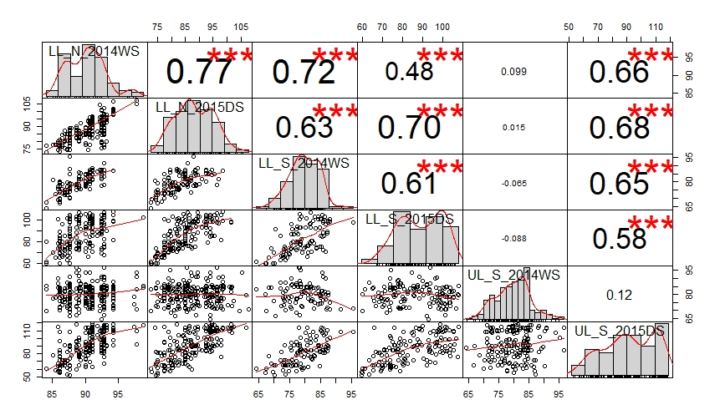
a

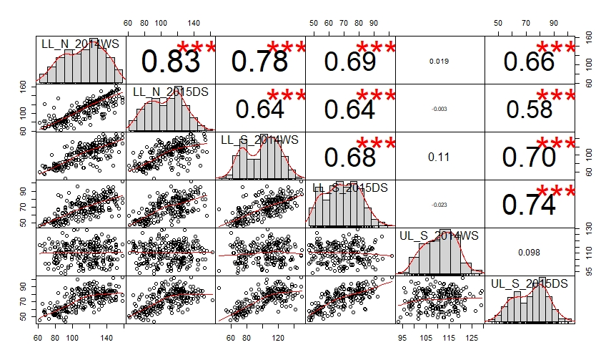
b

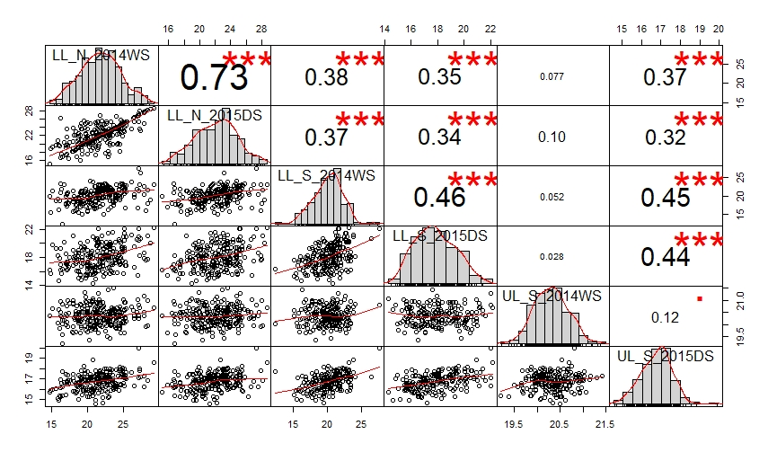
c

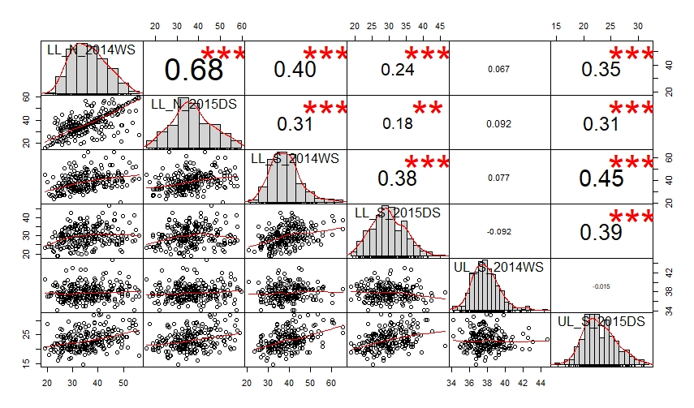
d

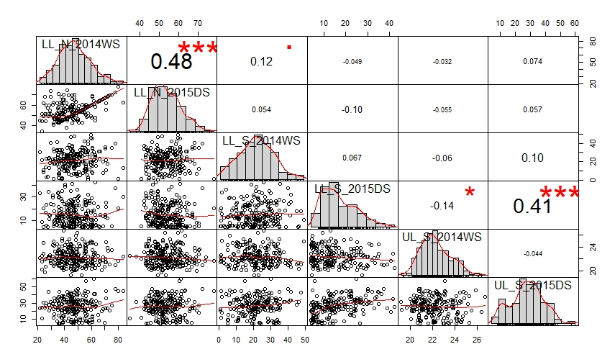
e

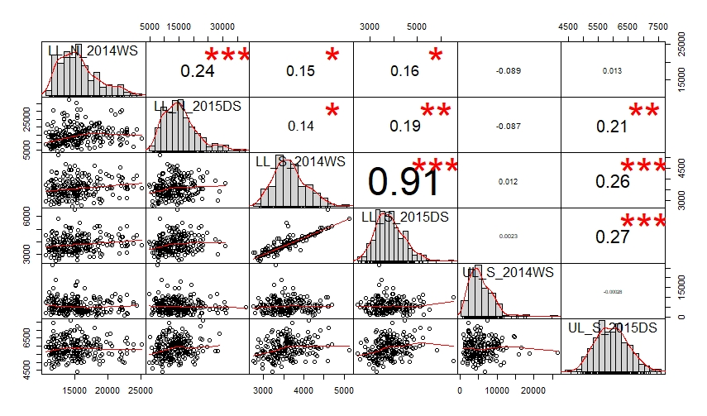
f

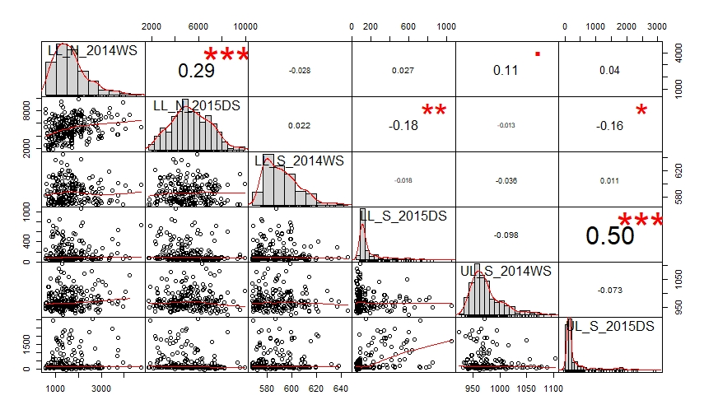
g

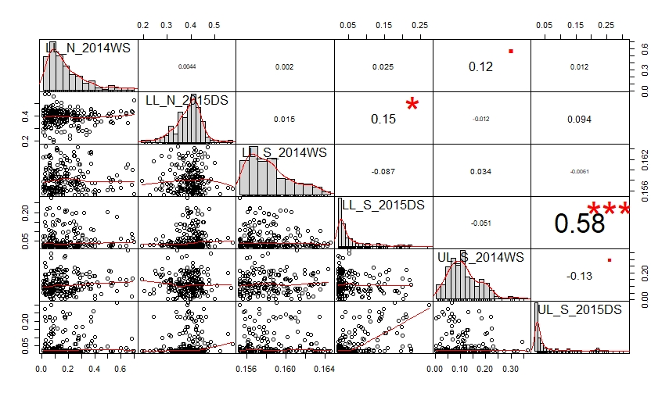
h

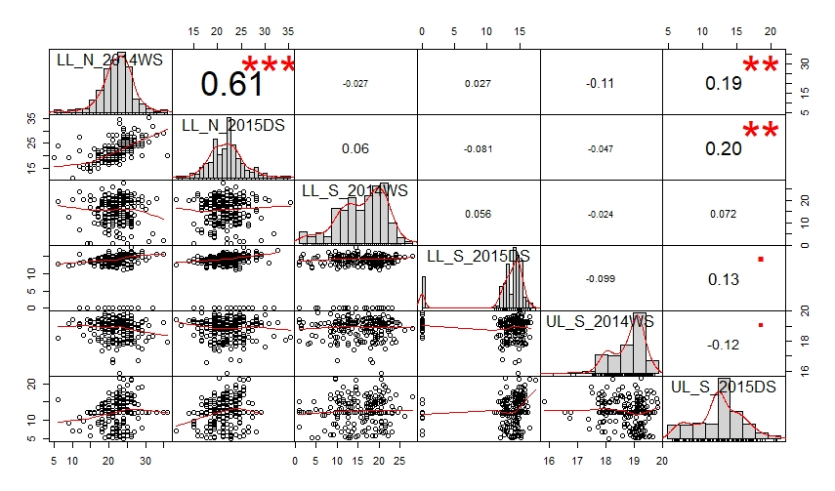
i

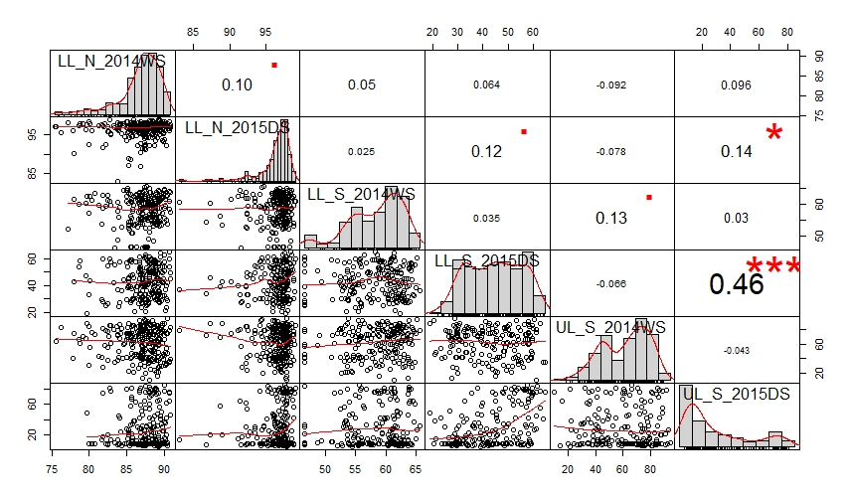
j

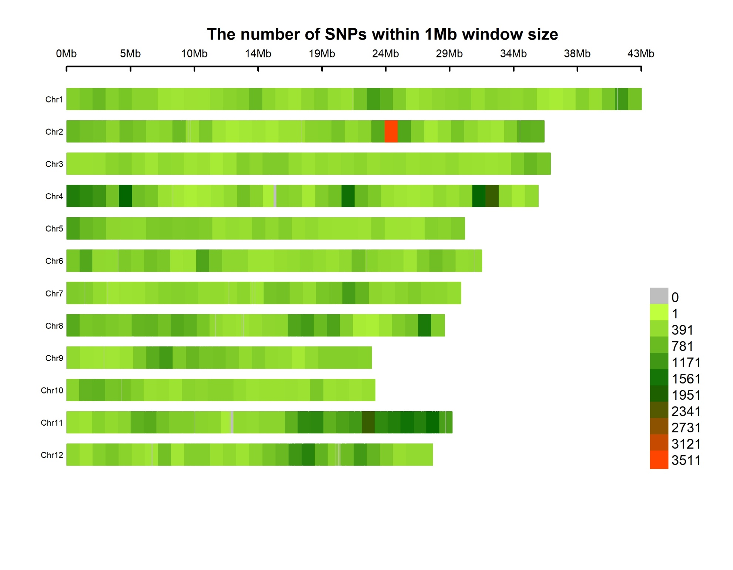
Figure S2 Heat map showing the uneven marker distribution along each of the 12 chromosomes using the 215,250 SNP working set

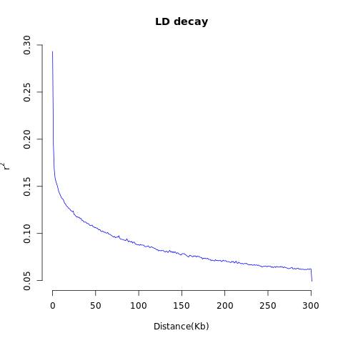
Figure S3 Pattern of rapid decay in linkage disequilibrium decay in the population of 280 accessions genotyped with 215,250 SNPs. The curve represents r² values plotted against pairwise distance between markers among the 12 chromosomes.

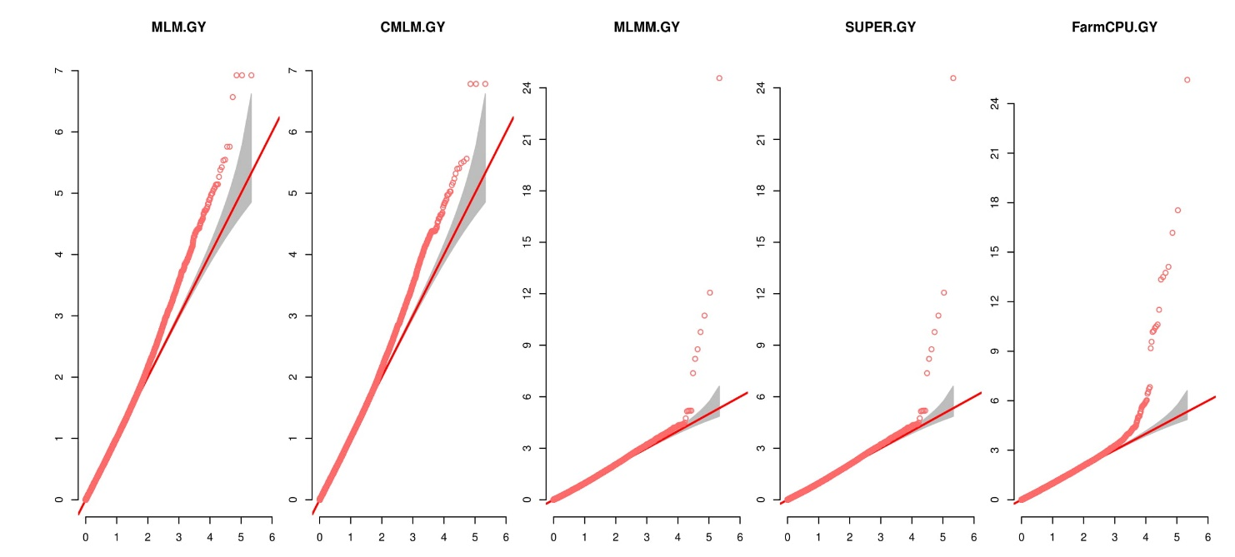
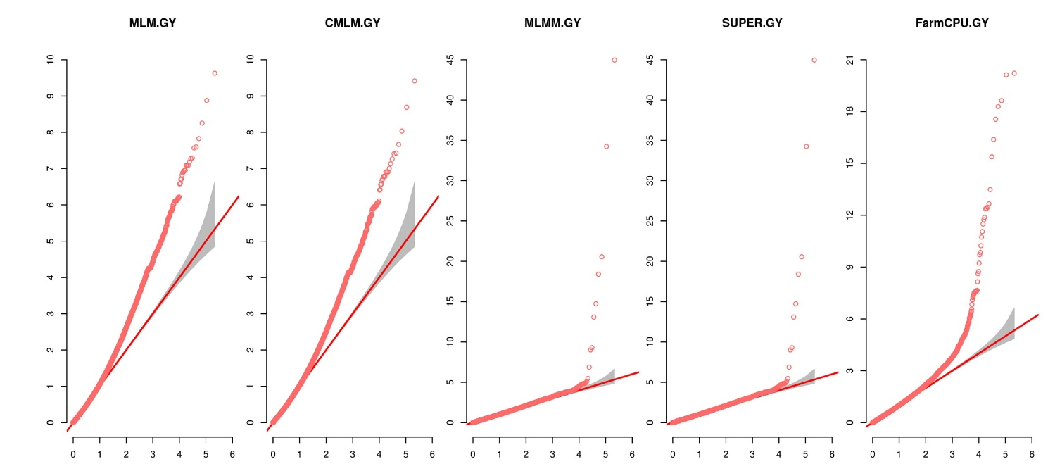
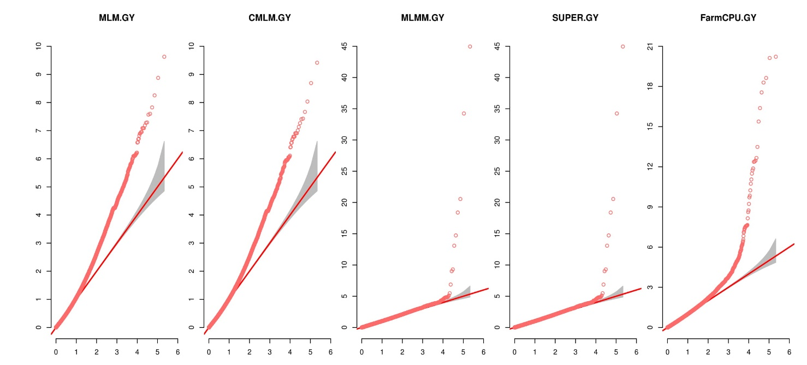
LL_S 2015DS
UL_S 2015DS
Figure S4 Effect of different algorithms in controlling p-value inflation – QQ plots for grain yield under lowland and upland stress in 2015DS exemplify the outperformance of Farm-CPU in distinguishing real association signals from background noise especially for complex quantitative traits like grain yield under severe reproductive-stage drought under lowland and upland environments.
λ=0.897
λ=0.862
λ=1.011
λ=0.913
λ=0.992
λ=0.982
λ=0.982
λ=0.93
a
b

